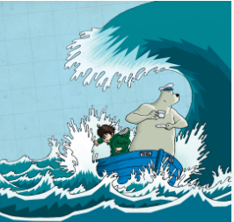

**Year 5**

**Spring 2**

History – Medevial MONACHS   
Learning about the past Monarchs, so we can understand how England is structured today. Including Elizabeth I, Henry VIII, Edward I and John I.

Maths

This term we are continuing with decimals and finding the equivalent percentage and fractions.

We will also be working out the perimeter and area of polygons, compound and rectilinear shapes. Using our knowledge of addition and multiplication to support this.

Finishing off the term with statistics, by collecting and presenting data in line graphs, tables and exploring timetables.

SCIENCE – Electrical circuits   
Investigating and experimenting to make and adapt electrical circuits. Including exploring insulators and conductors. As well as creating scientific diagrams to use as a plan to make a buzzer game.

English   
Using the book: The boy, a bear and a boat, we will go on an adventure and explore the characters dilemmas and trials. Looking into friendships and problem solving.

Using the book to influence our writing into poetry, letters, comics, descriptive pieces and story writing.

To accompany this, we will be using relative clauses and commas. As well as exploring different spelling patterns and homophones.

Welcome back. You have been very impressive over the last three terms!

Let’s keep the amazing work ethic and enthusiasm going.

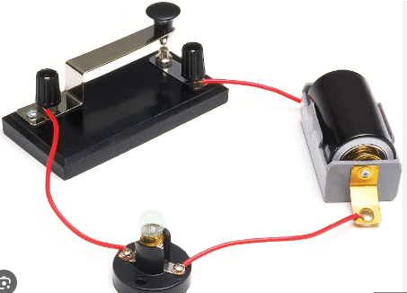

Design Technology   
Children will be able to explore simple burger recipes, learning how to adapt the recipe to improve nutritional content. As well as exploring how to sell the product they have created.

.



Jigsaw – Healthy me

Looking at how smoking, alcohol and how it can affect the body. As well as exploring body image and our relationships with food.

PE

Learning new skills for Tennis and handball. Including: how to control the ball, how to maintain a competitive rally, learning new footwork and the best ways to serve.

MUSIC – Holi festival

Exploring the associations between music, sound and colour; composing and performing their own musical composition to represent Holi – the Hindu festival.

.



RE – Easter   
Exploring the ideas of control and destiny to understand the events of Easter. Working out: if God in control or if it was Jesus` destiny. To work out what this means to Christian.

Computing – Micro: BIT

Children will have the chance to create animations, recognise input/outputs, choose appropriate blocks and break programmes down into smaller steps.

French – French speaking world   
Discovering the many French – speaking countries, giving and following directions in French as well as discussing climate using comparative language.

